Vegetarian Breakfast

Coffee/Tea Service Time (6:00 AM - 9:00AM)

Would you like fresh brewed coffee or hot water for tea outside of your room prior to breakfast service? Yes or No
Please Check: Coffee__ Decaf Coffee__ Hot Water__ (Milk __ Half & Half__ Almond Milk___)
What time would you prefer? (6am-9am) ______
Breakfast Time (7:00 AM - 9:30AM
Breakfast Location: In Room______ Courtyard______ Breakfast Time (Please Write): ________

Name: _____________
Date: ___________
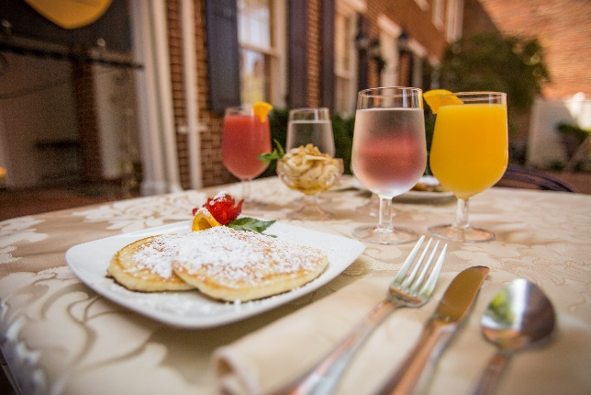
Beverages:
Coffee ______ Decaf Coffee_____
Tea ______ Cranberry Juice ____
Orange Juice_____
1840s Juice (Orange & Cranberry) ____

Starter:
Bananas w/ Nuts & Honey _____ Mixed Berries ________

Entrees: Select One

Fresh Eggs:
Scrambled: ________ (With Cheese?) _____
Fried: ______
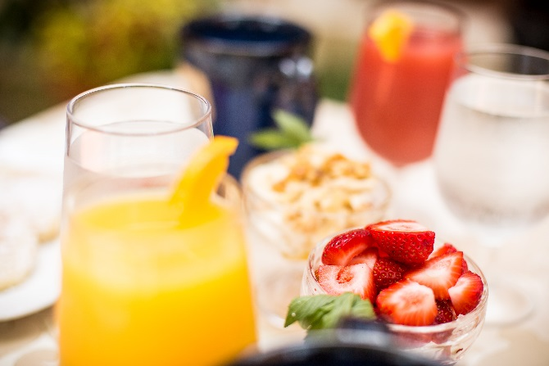
Poached: _____

1840s Omelet: _______
3 Eggs Scrambled, with tomato, onions, peppers, shiitake mushrooms,
cheese & fresh herbs

1840s Pancakes: _______
Fluffy pancakes (4) served either:
Plain____ Banana: ____
(*soy milk/non-dairy and egg replacer are used in baked goods)

Sides:
Vegan Sausage_____ Hash Browns _____
English Muffin_____ Wheat Toast____
Plain Pancakes (2) ___

Please fill out & put back on the door by 11:00 PM.
If you have any allergies or dietary restrictions, please let us know. Enjoy your Meal!

101 102 103 201 202 203 204 205 206 301 302 303 304

