Vegan Breakfast
Coffee/Tea Service Time (6:00 AM - 9:00AM)
Would you like fresh brewed coffee or hot water for tea outside of your room prior to breakfast service? Yes or No
Please Check: Coffee__ Decaf Coffee__ Hot Water__ (Almond Milk___)
What time would you prefer? (6am-9am) ______
Breakfast Time (7:00 AM - 9:30AM
Breakfast Location: In Room___ Courtyard___ Dining Room___ Breakfast Time): _____

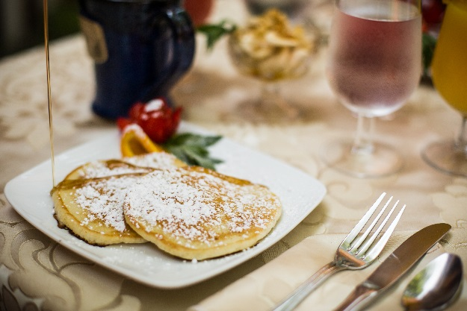
Name: _____________
Date: ___________
Beverages:
Coffee ______ Decaf Coffee_____
Tea ______ Cranberry Juice ____
Orange Juice_____
1840s Juice (Orange & Cranberry) ____

Starter:
Bananas w/ Nuts _____ Mixed Berries ________

Entrees: Select One
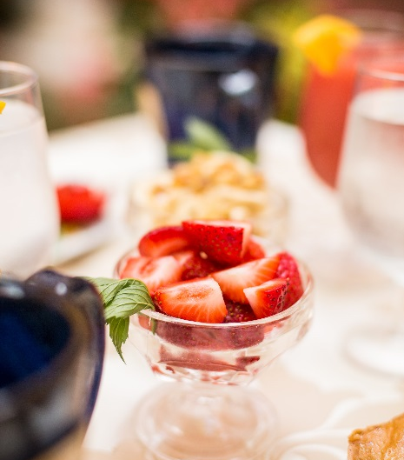
1840’s Potatoes_____
Delicious hand cut potatoes with a mix of
Tomatoes, onions, and fresh peppers

1840s Pancakes: _______
Fluffy pancakes (4) served either:
Plain____ Banana: ____
*Soy /non-dairy milk and egg replacer
are used in baked goods

Sides:

Vegan Sausage_____ Wheat toast _____

Please fill out & put back on the door by 11:00 PM.
If you have any allergies or dietary restrictions, please let us know. Enjoy your Meal!

101 102 103 201 202 203 204 205 206 301 302 303 304

