Gluten Free Breakfast

Coffee/Tea Service Time (6:00 AM - 9:00AM)

Would you like fresh brewed coffee or hot water for tea outside of your room prior to breakfast service? Yes or No
Please Check: Coffee__ Decaf Coffee__ Hot Water__ (Milk __ Half & Half__ Almond Milk___)
What time would you prefer? (6am-9am) ______
Breakfast Time (7:00 AM - 9:30AM
Breakfast Location: In Room______ Courtyard______
Breakfast Time (Please Write): ________

Name: _____________
..Date: ___________

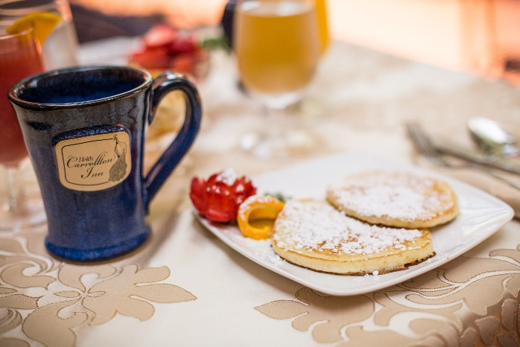
Beverages:
Coffee ______ Decaf Coffee_____
Tea ______ Cranberry Juice ____
Orange Juice_____
1840s Juice (Orange & Cranberry) ____

Starter:
Bananas w/ Nuts & Honey _____ Mixed Berries ________

Entrees: Select One

Fresh Eggs:
Scrambled: ________ (With Cheese?) _____
Fried: ______
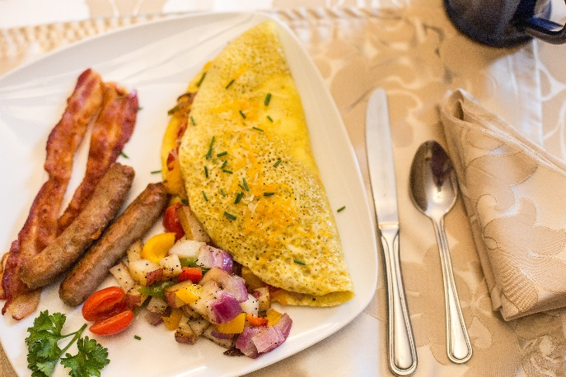
Poached: _____

1840s Omelette: _______
3 Eggs Scrambled, with tomato, onions, peppers, shiitake mushrooms
Cheese & fresh herbs

1840s Pancakes: _______
Fluffy pancakes (4) served either:
Plain*: _____ Banana*:____
*Made with gluten-free pancake mix*

Sides:
Bacon ______ Sausage_____
Vegan Sausage ______ Hash Browns _____

Please fill out & put back on the door by 11:00 PM.
If you have any allergies or dietary restrictions, please let us know.
Vegetarian, vegan, and gluten free menus are available upon request. Enjoy your Meal!

101 102 103 201 202 203 204 205 206 301 302 303 304

